Navy – Chinese Sit-ups

Reference: **CHINESE_SITUPS**

Two people will form a group. They will face each other both lay on their backs near each other. One member will place his/her feet under the other member’s rear whose feet are spread apart. Each member will place one wrist over the other and then proceed to grab the hands of their partner. The exercise will consist of the member whose feet are underneath the other members body to crunch forward and to stand tall. The member whose feet are spread apart can help the other person to complete a rep by rocking back and pulling the other member. One rep will be counted once the person crunches forward, stands tall and goes back to the start position.

Illustrated below:

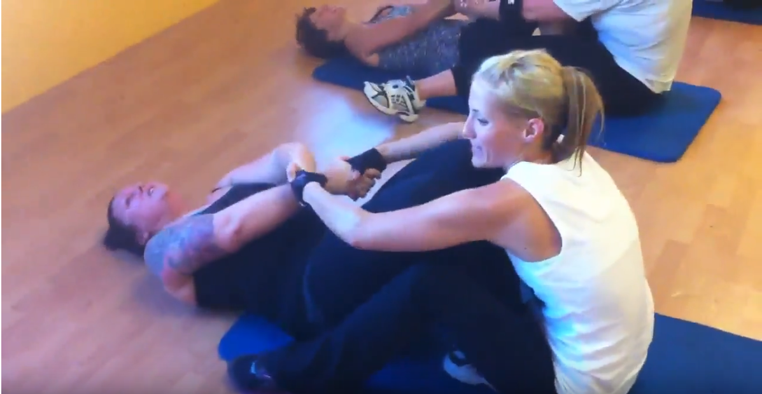

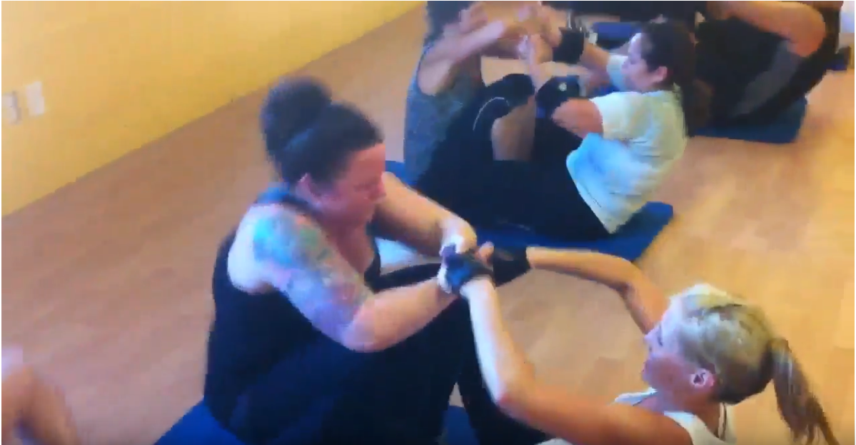

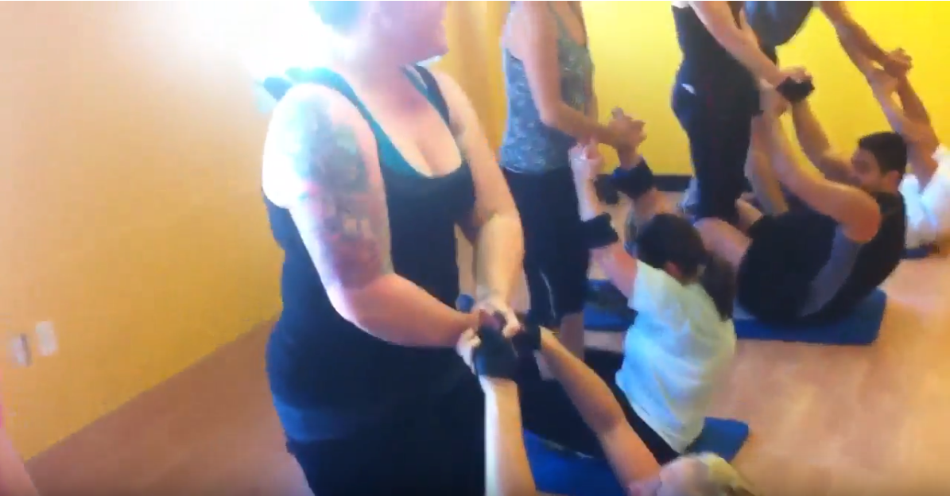

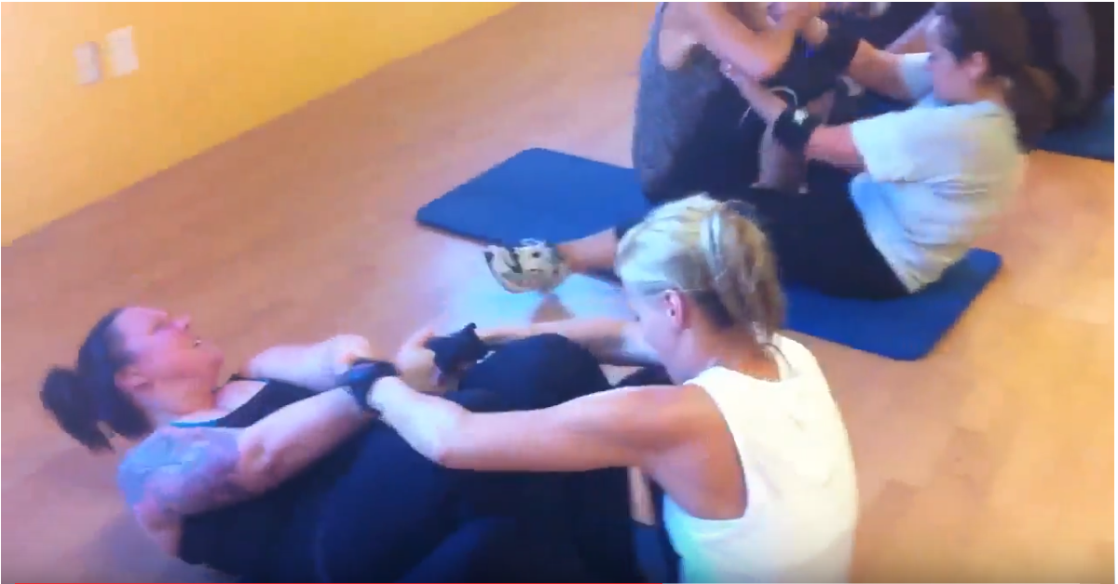

Reference YouTube Video: https://www.youtube.com/watch?v=T1V-437JkFc